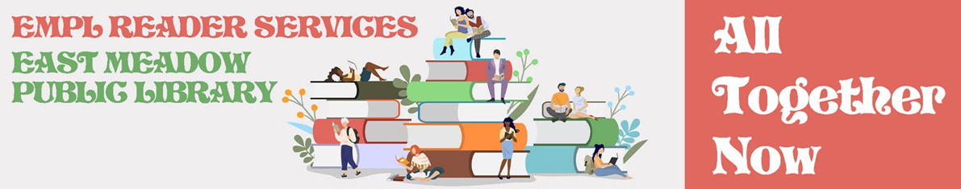
TIC-TAC-TOE
A title cannot be used in more than one square.
A book about a family or group of friends  Tile:  Author | A genre book  (Mystery, Romance, SF, Fantasy)  Tile:  Author | A non-fiction book  Tile:  Author
A book set during the 1960s  Tile:  Author | A book from the All Together Now Bibliography  Tile:  Author | A book with one of these words in the title:  “All” “Together” “Now”  Tile:  Author
A Book featuring a LGBTQIA+ character  Tile:  Author | A book with a cover that has more than one person on it  Tile:  Author | An E-book  Tile:  Author

